**Data structure lab**

**Megha Patel 20124107**

**Union**

1. **Write a program in C to show a pointer to union**.

#include <stdio.h>

union megha

{

char name[20];

};

void main()

{

int i;

union megha *s,s1;

s = &s1;

printf("\nEnter your name: \t");

scanf("%s",s->name);

printf("name is = %s",s->name);

}

​ 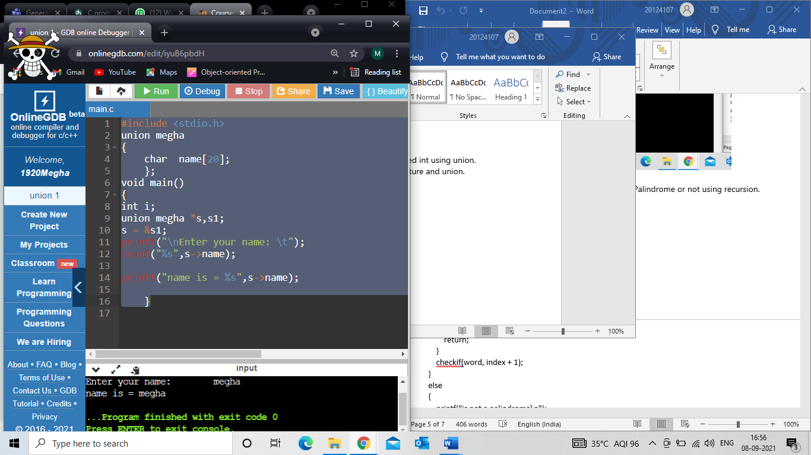

1. **Write a program in C to extract individual bytes from an unsigned int using union.**

#include<stdio.h>

union u

{

unsigned int a;

unsigned char s[4];

};

union u object;

int main()

{

int i;

printf("ener a unsigned int\n");

scanf("%u",&object.a);

printf("Indivisual bytes: ");

for(i=3;i>=0;i--)

printf("%02X ",object.s[i]);

printf("\n");

return 0;

}

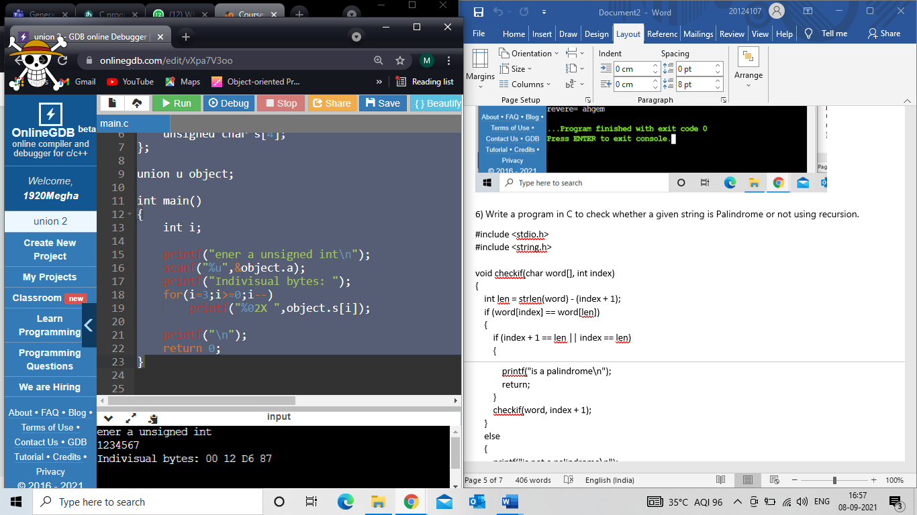

1. **Write a program in C demonstrate the difference** **between structure and union.**

#include <stdio.h>

struct S

{

int i;

char c[50];

float f;

};

union u

{

int i;

char c[50];

float f;

};

int main()

{

struct S s1;

union u u1;

printf(" to show difference between sizes occupied by structre and union \n Structure = %d\n", sizeof (s1) );

printf(" Union = %d\n", sizeof(u1));

return 0;

}

